1.

#include <stdio.h>

int main()

{

void check(int,float,double);

int x;

float y;

double z;

printf("Enter the int number:");

scanf("%d",&x);

printf("\nEnter the float number:");

scanf("%f",&y);

printf("\nEnter the double number:");

scanf("%lf",&z);

check(x,y,z);

return 0;

}

void check(int x,float y,double z)

{

printf("x:%d,y:%f,z:%lf",x,y,z);

}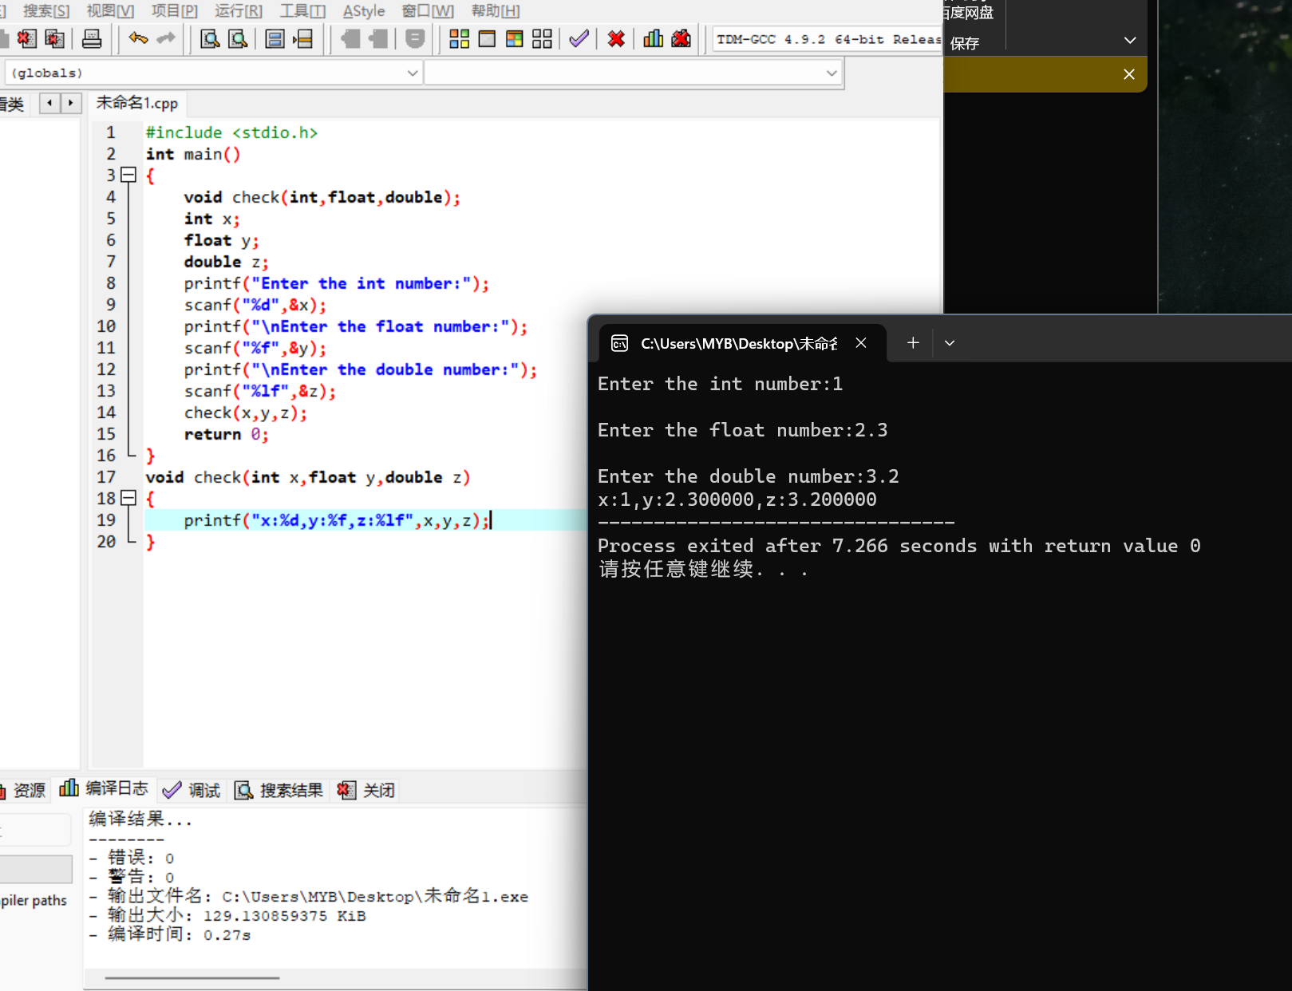

2.

#include <stdio.h>

int main()

{

double findAbs(double);

double a;

printf("Enter a number:");

scanf("%lf",&a);

printf("%lf",findAbs(a));

return 0;

}

double findAbs(double x)

{

if(x>=0)

return x;

else

return -x;

}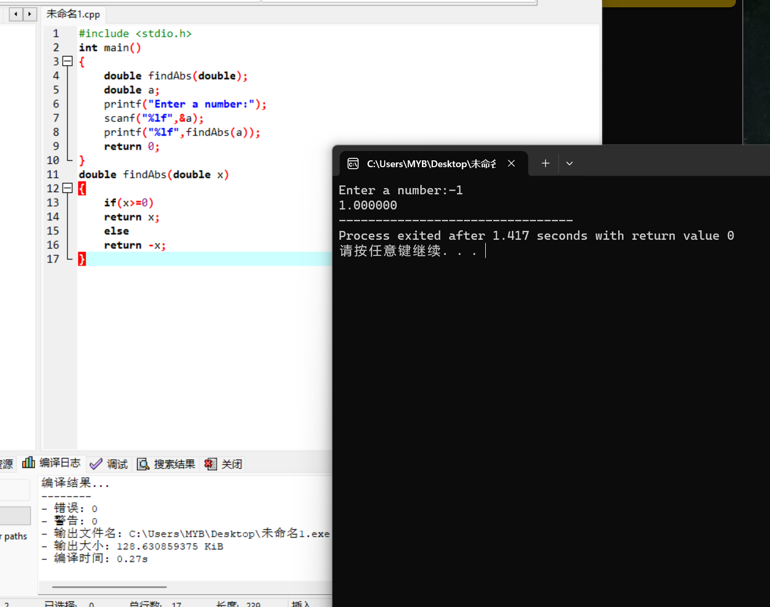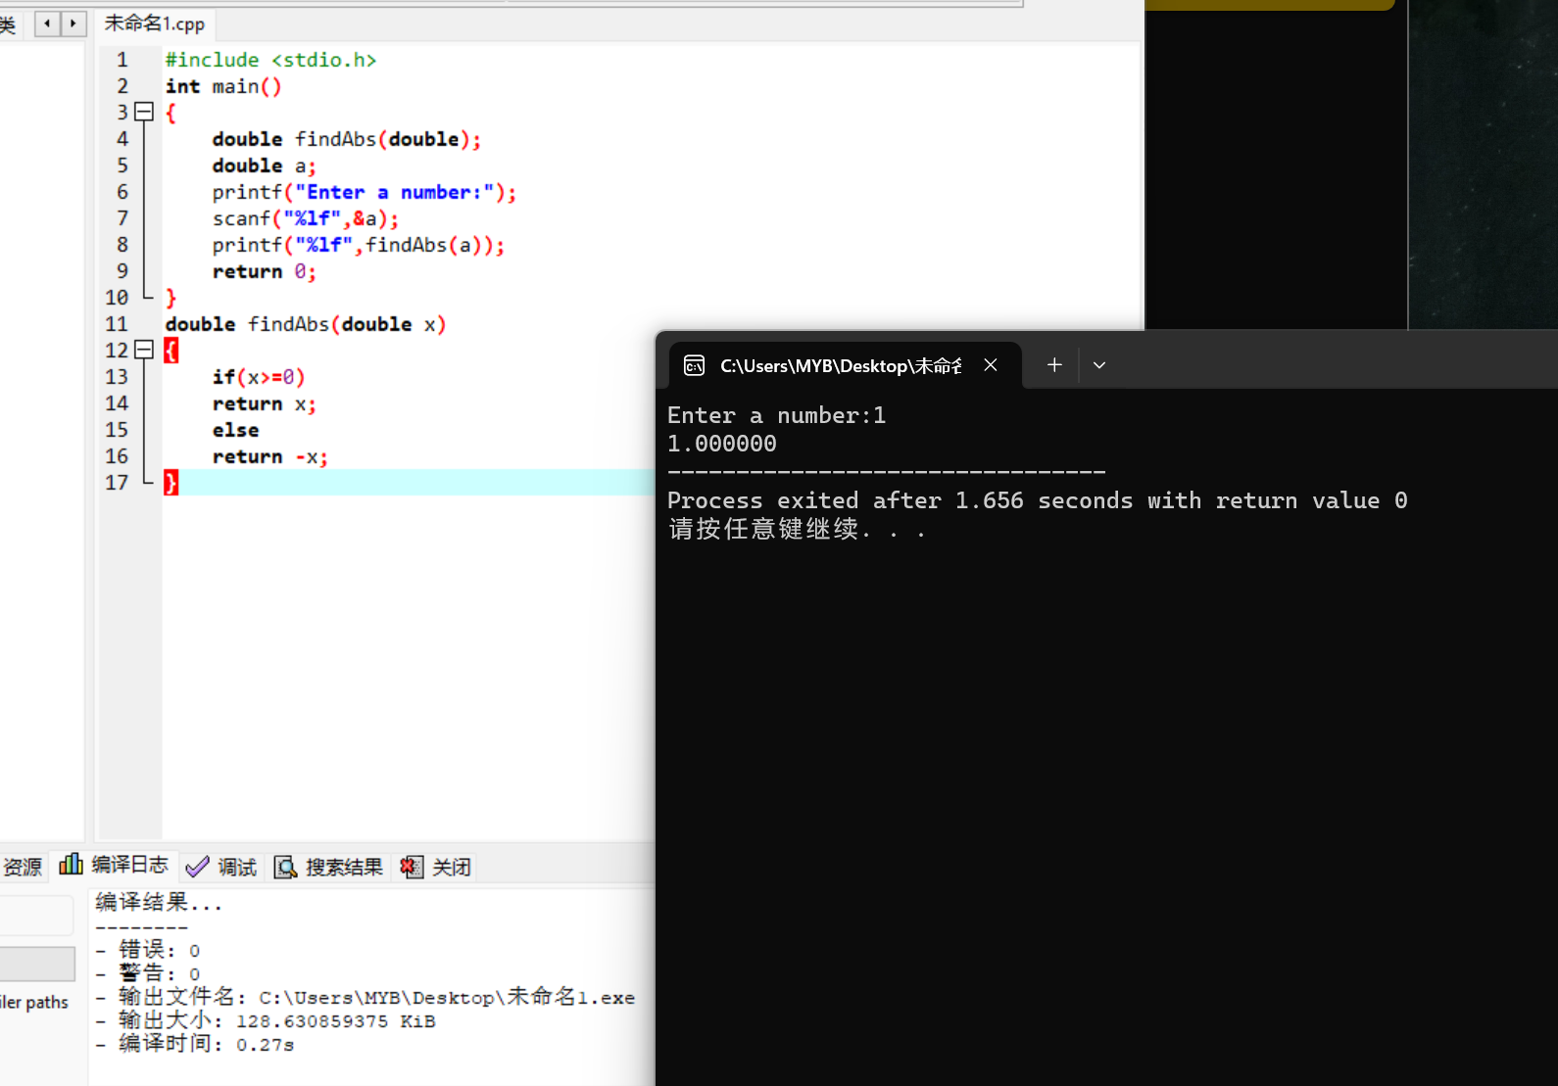

3.

#include <stdio.h>

int main()

{

double mult(double,double);

double a,b;

printf("Enter two double number:");

scanf("%lf %lf",&a,&b);

printf("a\*b=%lf",mult(a,b));

return 0;

}

double mult(double x,double y)

{

double mult;

mult=x\*y;

return mult;

}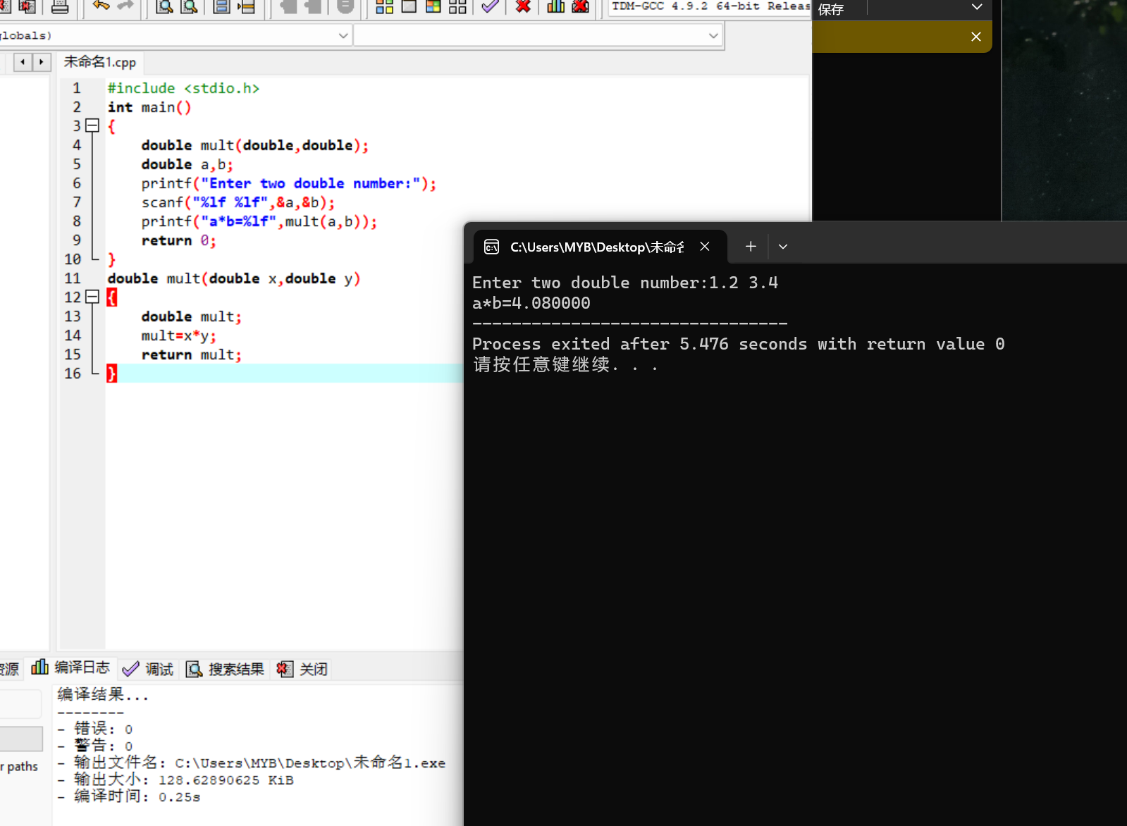

4.

#include <stdio.h>

int main()

{

double squareIt(double);

double a;

printf("Enetr the number:");

scanf("%lf",&a);

printf("The number's square is :%lf",squareIt(a));

return 0;

}

double squareIt(double x)

{

double s;

s=x\*x;

return s;

}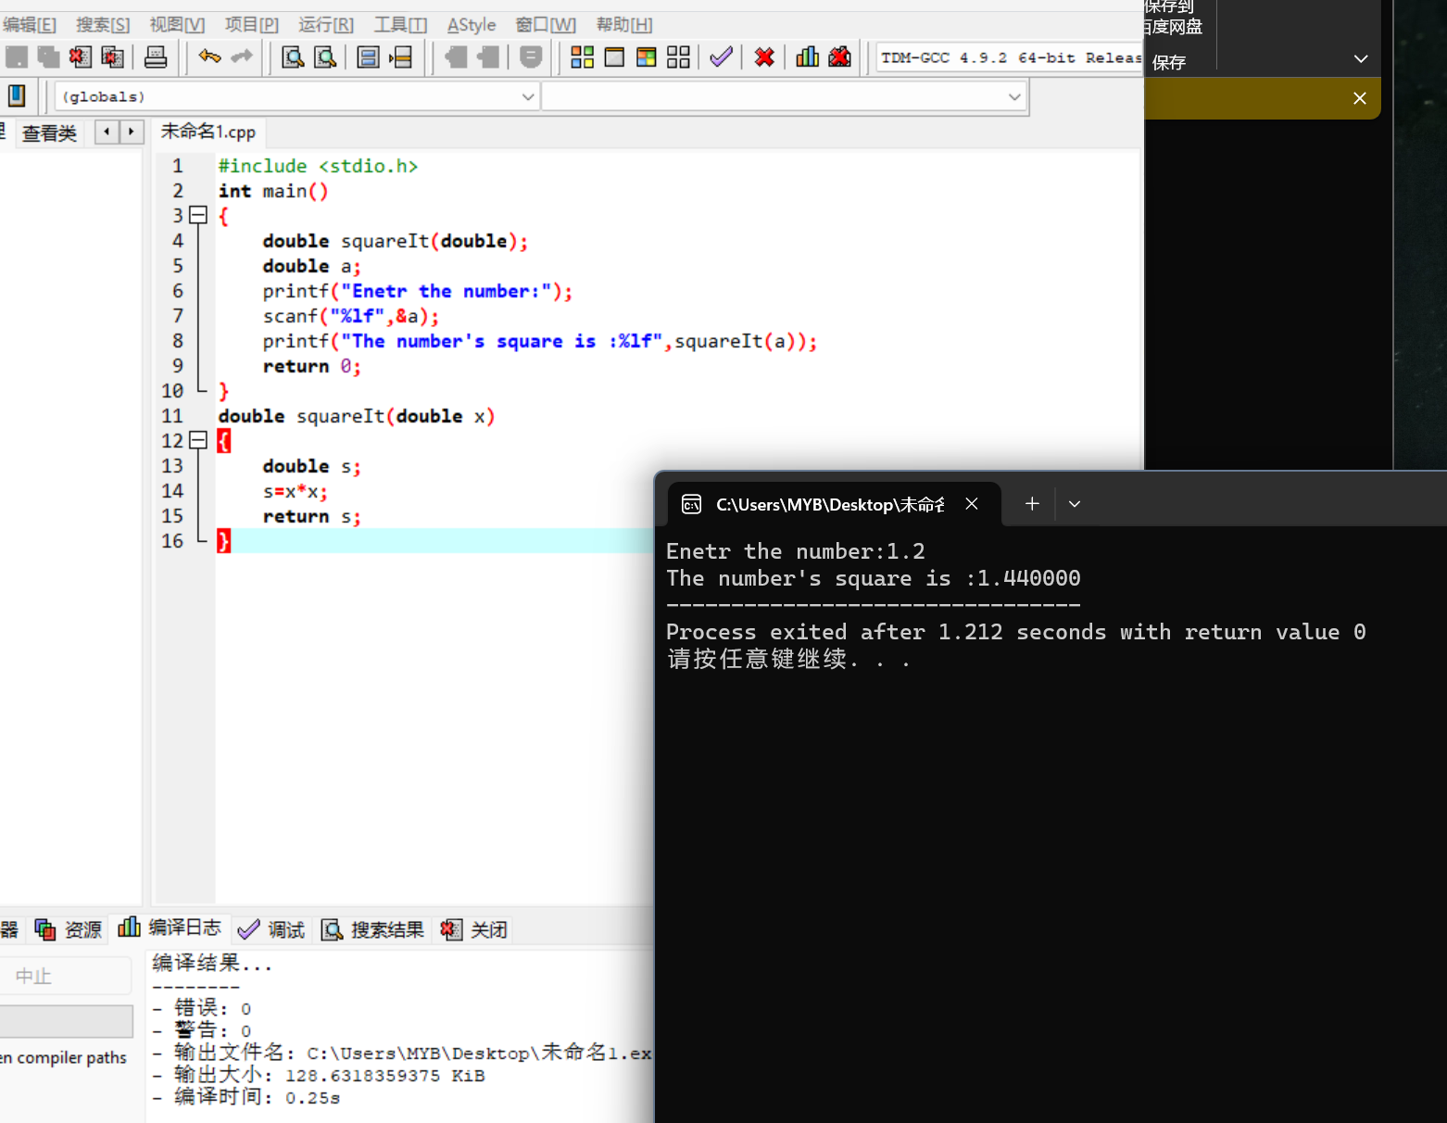

5.

#include <stdio.h>

int main()

{

int powfun(int,int);

int a,b;

printf("Enter two numbers:");

scanf("%d,%d",&a,&b);

printf("The final number is:%d",powfun(a,b));

return 0;

}

int powfun(int x,int y)

{

int i,mul=x;

for(i=1;i<y;i++)

{

mul=mul\*x;

}

return mul;

}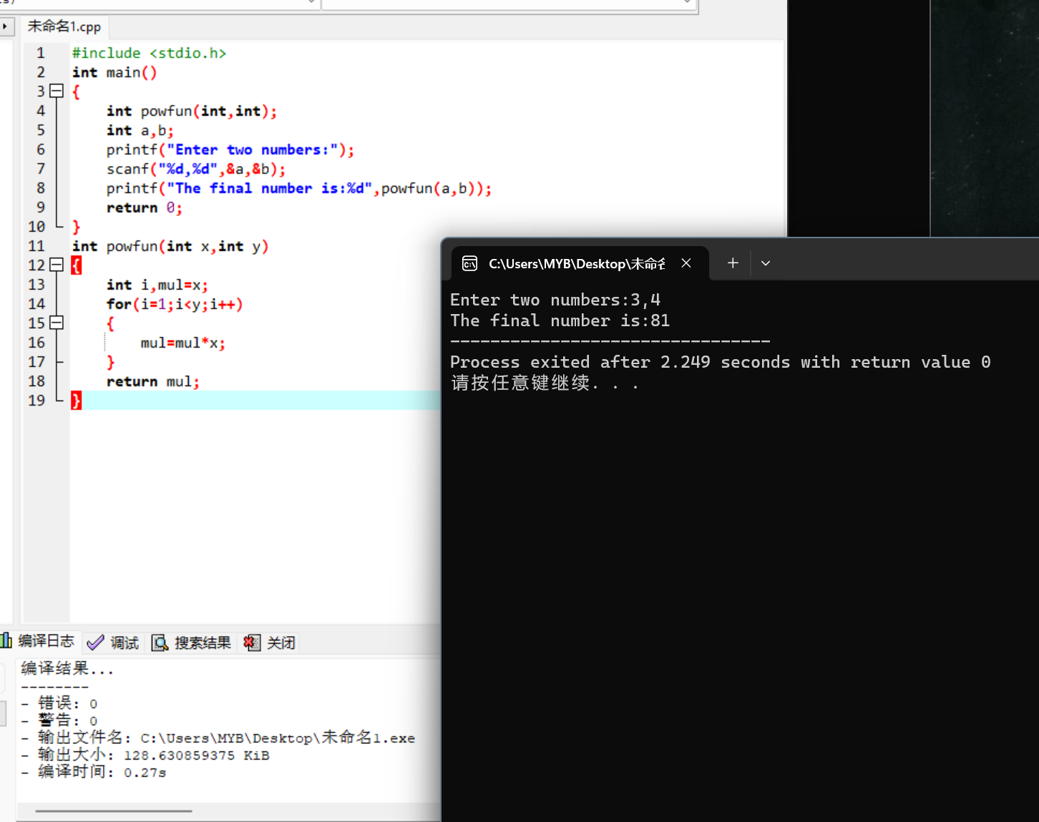

6.

#include <stdio.h>

int main()

{

void selecTable(int,int,int);

int a,b,c;

printf("Enter three numbers:");

scanf("%d,%d,%d",&a,&b,&c);

selecTable(a,b,c);

return 0;

}

void selecTable(int a,int b,int c)

{

int i,j;

for(i=1;i<=b;i++)

{

printf("%d\n",a);

a+=c;

}

}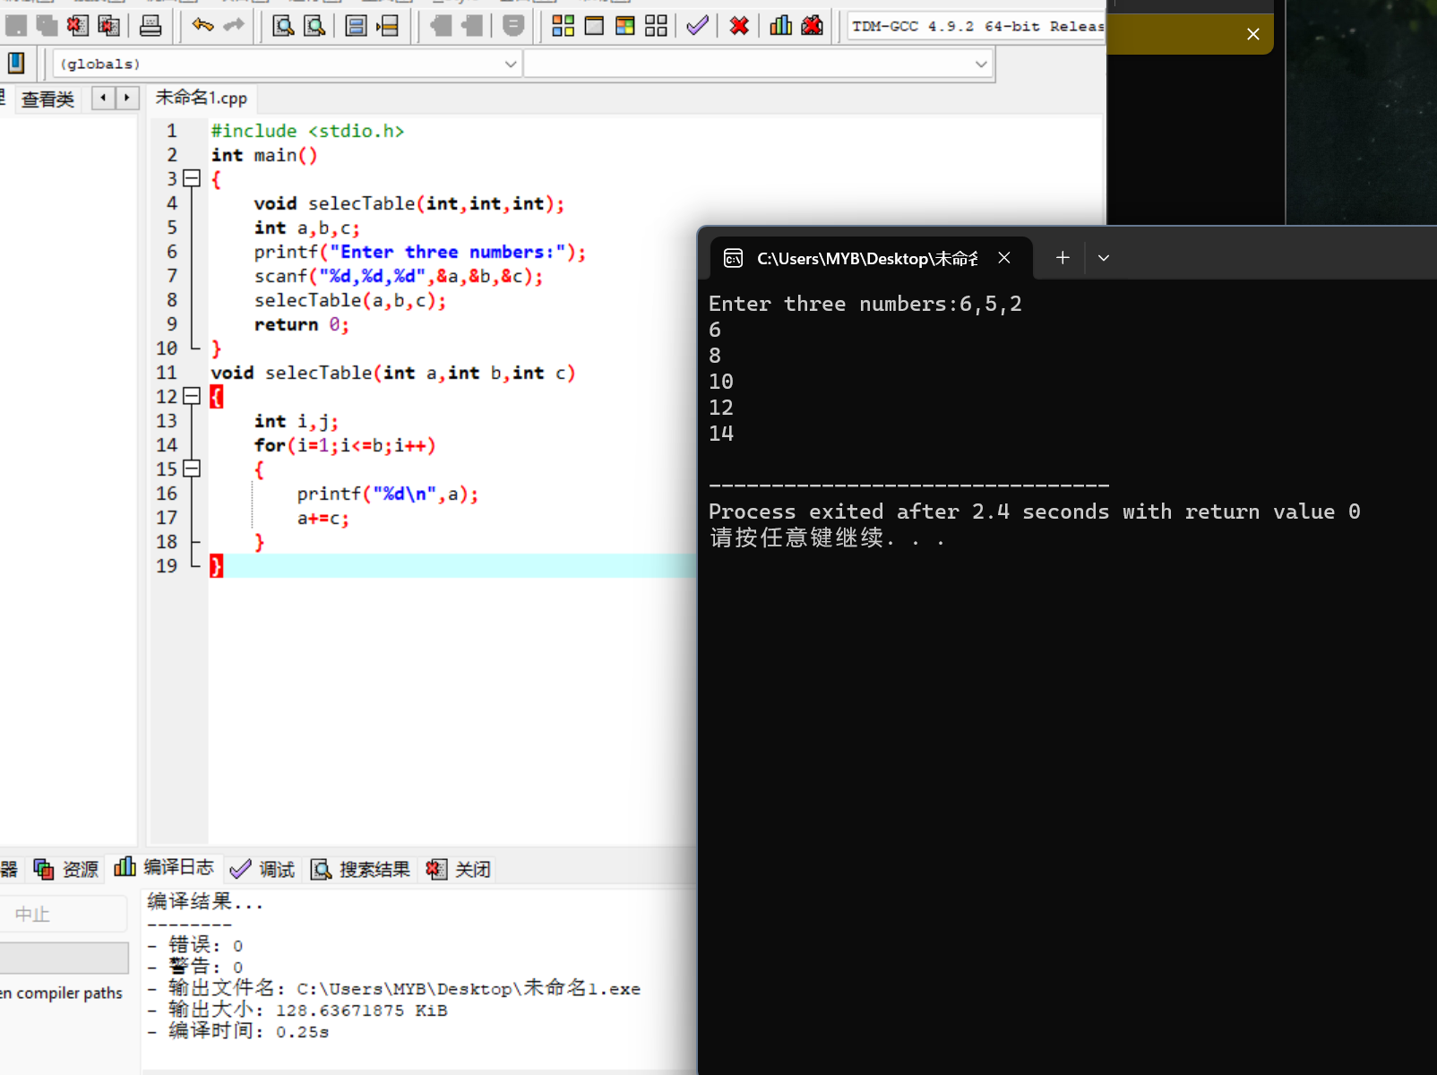

7.

#include <stdio.h>

int main()

{

void check(int);

int a;

printf("Enter a number :");

scanf("%d",&a);

check(a);

return 0;

}

void check(int a)

{

if(a%2==0)

printf("It is even.");

else

printf("It is odd.");

}

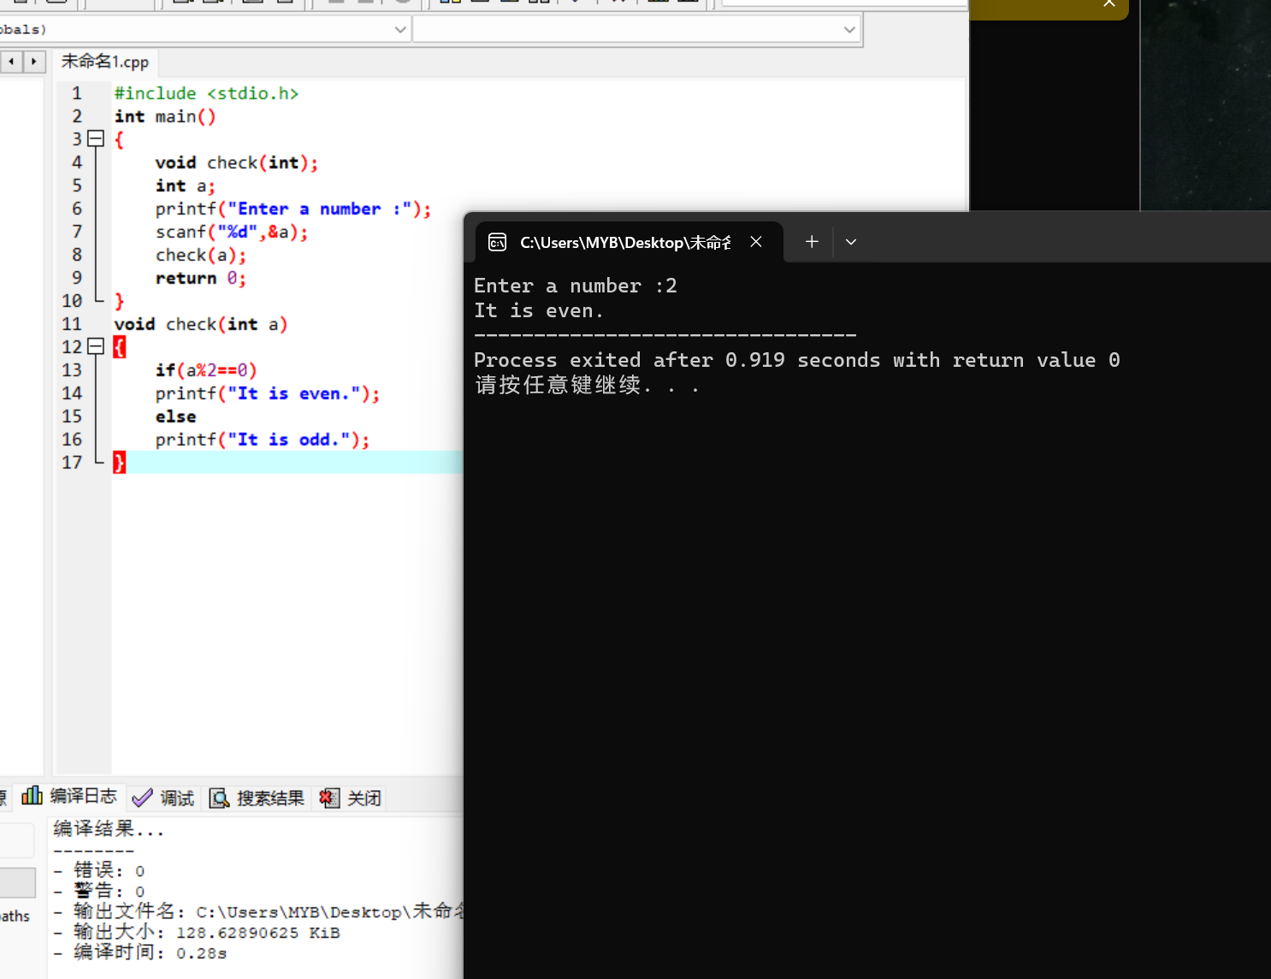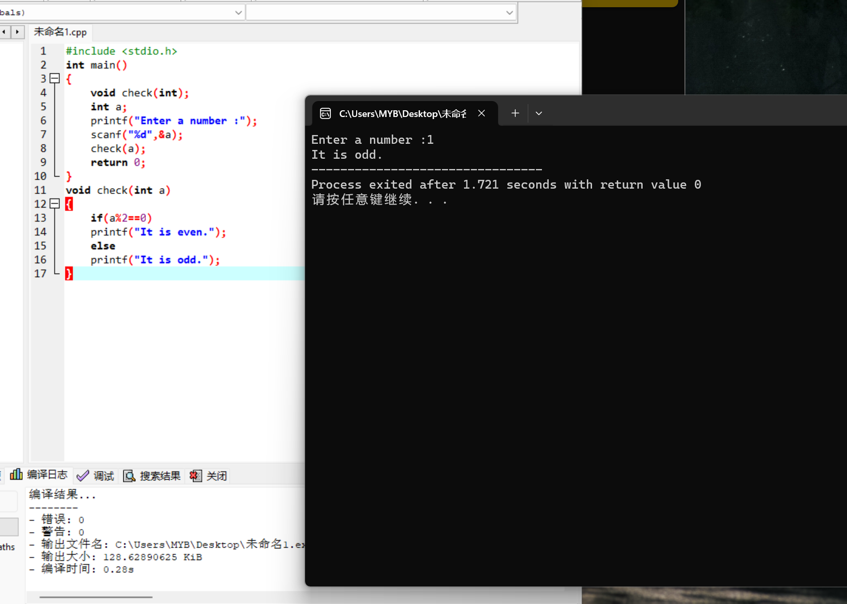

8.

#include <stdio.h>

#include <math.h>

int main()

{

float hypotenuse(float,float);

float a,b;

printf("Enter a,b:");

scanf("%f,%f",&a,&b);

printf("C is :%f",hypotenuse(a,b));

return 0;

}

float hypotenuse(float x,float y)

{

float c;

c=sqrt(pow(x,2)+pow(y,2));

return c;

}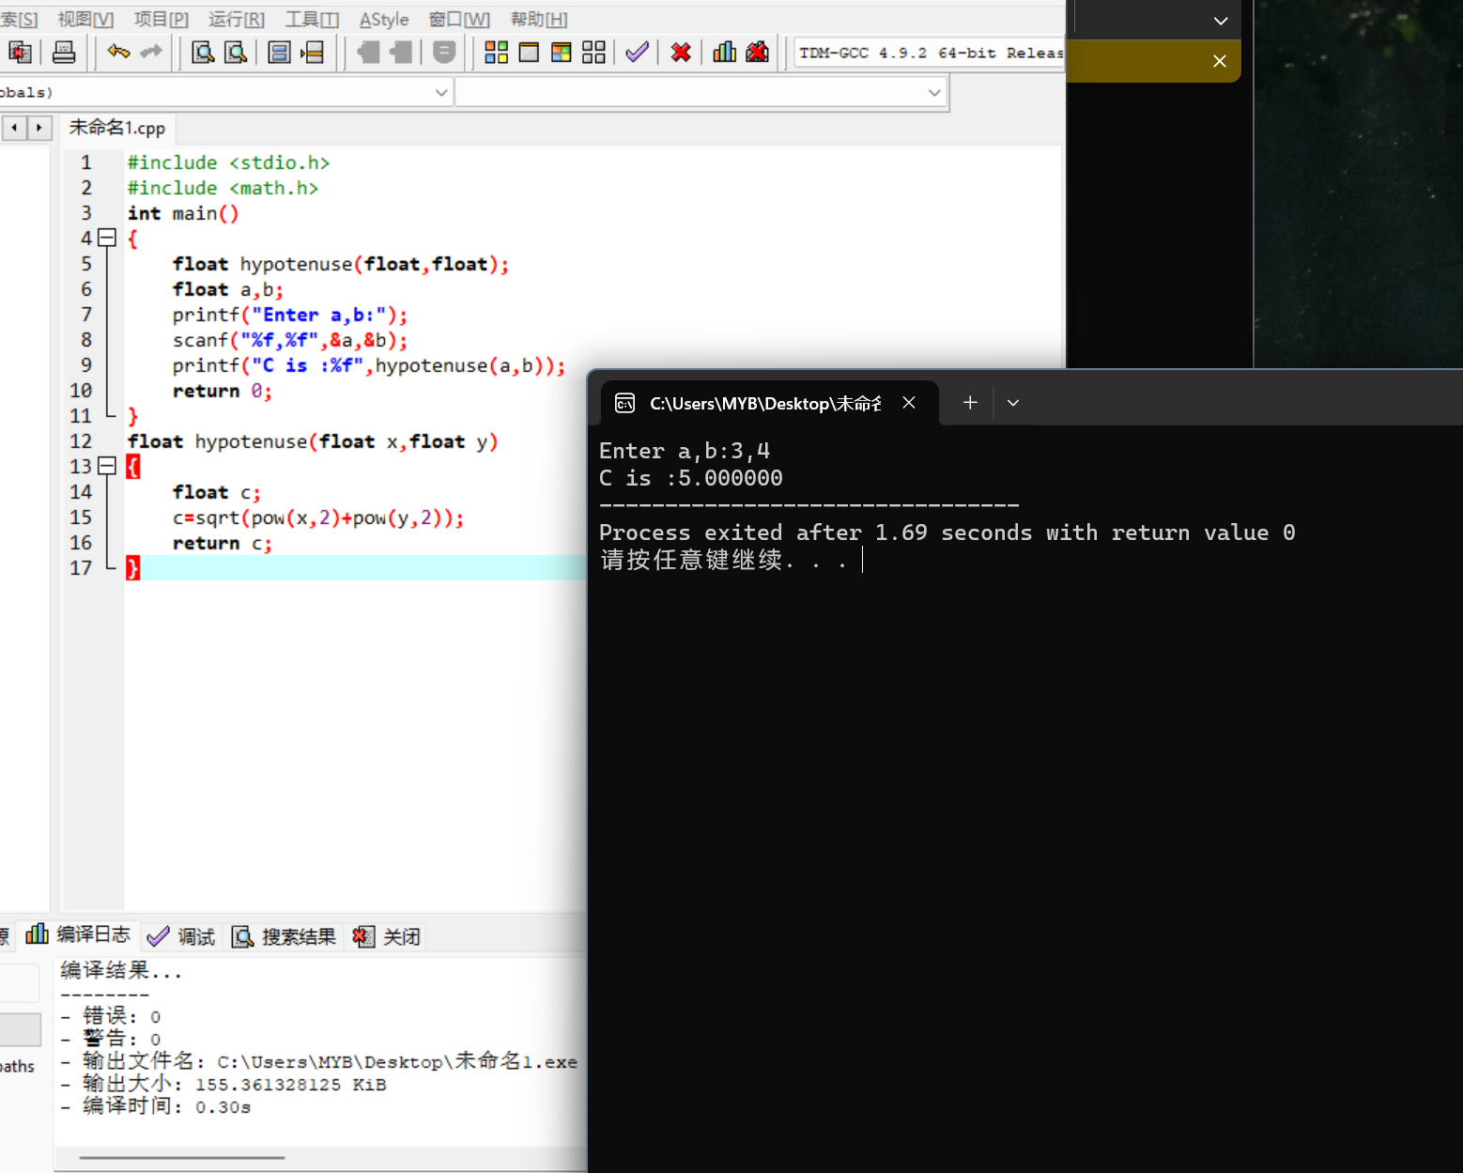

9.

#include <stdio.h>

#define Q 0.25

#define D 0.10

#define N 0.05

#define P 0.01

int main()

{

float totamt(int,int,int,int);

int q,d,n,p;

printf("Enter the number of quarters,dims,nickels and pennies:");

scanf("%d,%d,%d,%d",&q,&d,&n,&p);

printf("The dollars :%f",totamt(q,d,n,p));

return 0;

}

float totamt(int a,int b,int c,int d)

{

float num;

num=a\*Q+b\*D+c\*N+d\*P;

return num;

}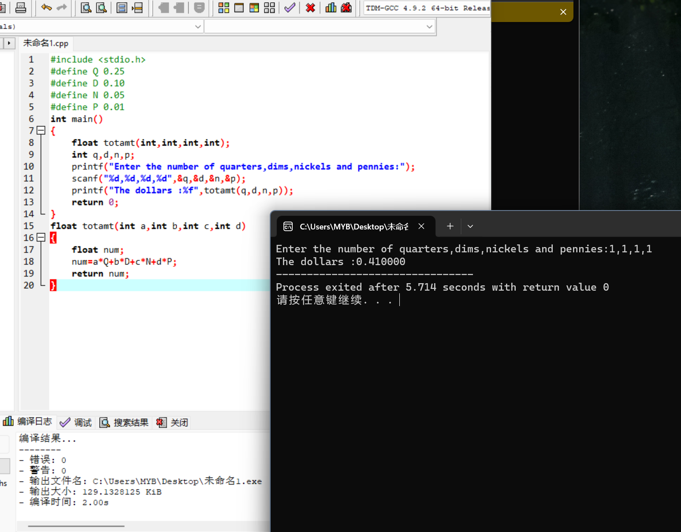

10.

#include <stdio.h>

#include <math.h>

int main()

{

double distance(double,double,double,double);

double x1,y1,x2,y2;

printf("Enter the first point:");

scanf("%lf,%lf",&x1,&y1);

printf("Enter the second point:");

scanf("%lf,%lf",&x2,&y2);

printf("The distance between twos points is :%lf",distance(x1,y1,x2,y2));

return 0;

}

double distance(double x1,double y1,double x2,double y2)

{

double D;

D=sqrt(pow(x2-x1,2)+pow(y2-y1,2));

return D;

}